**P1. Consider the network below.**

**a. Show the forwarding table in router A, such that all traffic destined to host H3 is forwarded through interface 3.**

**b. Can you write down a forwarding table in router A, such that all traffic from H1 destined to host H3 is forwarded through interface 3, while all traffic from H2 destined to host H3 is forwarded through interface 4? (Hint: This is a trick question.)**

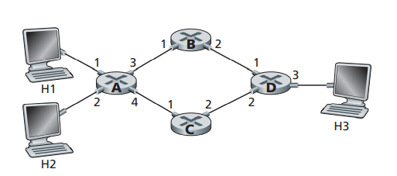

a) Destination address: H3 Link interface: 3

b) No.

A forwarding table in router A cannot be configured so that all traffic from H1 meant for host H3 is routed through interface 3, while all traffic from H2 destined for host H3 is routed through interface 4.

**P2. Suppose two packets arrive to two different input ports of a router at exactly the same time. Also suppose there are no other packets anywhere in the router.**

**a. Suppose the two packets are to be forwarded to two different output ports. Is it possible to forward the two packets through the switch fabric at the same time when the fabric uses a shared bus?**

**b. Suppose the two packets are to be forwarded to two different output ports. Is it possible to forward the two packets through the switch fabric at the same time when the fabric uses switching via memory?**

**c. Suppose the two packets are to be forwarded to the same output port. Is it possible to forward the two packets through the switch fabric at the same time when the fabric uses a crossbar?**

a) No

b) No

c) Yes

**P6. Consider the figure below. Answer the following questions:**

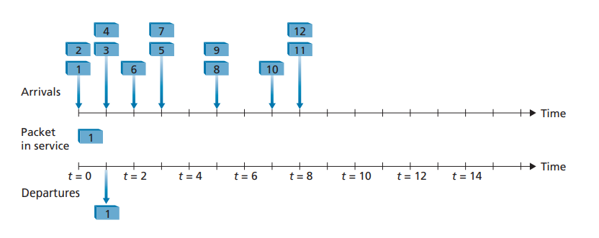

**a. Assuming FIFO service, indicate the time at which packets 2 through 12 each leave the queue. For each packet, what is the delay between its arrival and the beginning of the slot in which it is transmitted? What is the average of this delay over all 12 packets?**

**b. Now assume a priority service, and assume that odd-numbered packets are high priority, and even-numbered packets are low priority. Indicate the time at which packets 2 through 12 each leave the queue. For each packet, what is the delay between its arrival and the beginning of the slot in which it is transmitted? What is the average of this delay over all 12 packets?**

**c. Now assume round robin service. Assume that packets 1, 2, 3, 6, 11, and 12 are from class 1, and packets 4, 5, 7, 8, 9, and 10 are from class 2. Indicate the time at which packets 2 through 12 each leave the queue. For each packet, what is the delay between its arrival and its departure? What is the average delay over all 12 packets?**

**d. Now assume weighted fair queueing (WFQ) service. Assume that oddnumbered packets are from class 1, and even-numbered packets are from class 2. Class 1 has a WFQ weight of 2, while class 2 has a WFQ weight of 1. Note that it may not be possible to achieve an idealized WFQ schedule as described in the text, so indicate why you have chosen the particular packet to go into service at each time slot. For each packet what is the delay between its arrival and its departure? What is the average delay over all 12 packets?**

**e. What do you notice about the average delay in all four cases (FIFO, RR, priority, and WFQ)?**

a) Packet 1: delay=0;

Packet 2: delay=1;

Packet 3: delay=1;

Packet 4: delay=2;

Packet 5: delay=2;

Packet 6: delay=2;

Packet 7: delay=3;

Packet 8: delay=2;

Packet 9: delay=3;

Packet 10: delay=2;

Packet 11: delay=2;

Packet 12: delay=3;

The average delay of this delay over all 12 packets is: average delay =23/12

b) Packet 1: delay=0;

Packet 2: delay=2;

Packet 3: delay=0;

Packet 4: delay=5;

Packet 5: delay=0;

Packet 6: delay=5;

Packet 7: delay=1;

Packet 8: delay=4;

Packet 9: delay=0;

Packet 10: delay=3;

Packet 11: delay=0;

Packet 12: delay=3;

The average delay of this delay over all 12 packets is: average delay =23/12

c) Packet 1: delay=0;

Packet 2: delay=2;

Packet 3: delay=3;

Packet 4: delay=0;

Packet 5: delay=0;

Packet 6: delay=4;

Packet 7: delay=2;

Packet 8: delay=2;

Packet 9: delay=4;

Packet 10: delay=4;

Packet 11: delay=0;

Packet 12: delay=2;

The average delay of this delay over all 12 packets is: average delay =23/12

d) Packet 1: delay=0;

Packet 2: delay=2;

Packet 3: delay=0;

Packet 4: delay=4;

Packet 5: delay=0;

Packet 6: delay=5;

Packet 7: delay=1;

Packet 8: delay=4;

Packet 9: delay=1;

Packet 10: delay=3;

Packet 11: delay=0;

Packet 12: delay=3;

The average delay of this delay over all 12 packets is: average delay =23/12

e) The average delay in four cases is the same.

**P8. Consider a datagram network using 32-bit host addresses. Suppose a router has four links, numbered 0 through 3, and packets are to be forwarded to the link interfaces as follows:**

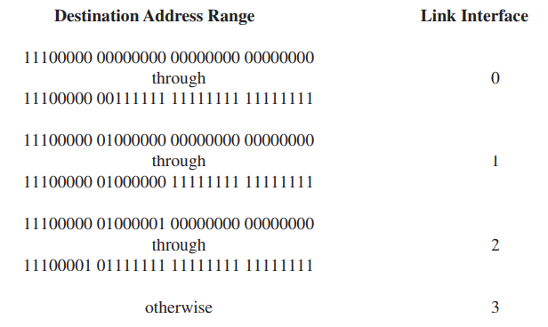

**a. Provide a forwarding table that has five entries, uses longest prefix matching, and forwards packets to the correct link interfaces.**

**b. Describe how your forwarding table determines the appropriate link interface for datagrams with destination addresses:**

**11001000 10010001 01010001 01010101**

**11100001 01000000 11000011 00111100**

**11100001 10000000 00010001 01110111**

|  |
| --- |
| Prefix Match Link Interface |
| 11100000 0 |
| 11100001 00000000 1 |
| 11100001 2 |
| otherwise 3 |

a)

b) Prefix match for first address is 4th entry: link interface 3

Prefix match for second address is 2nd entry: link interface 1

Prefix match for first address is 3rd entry: link interface 2

**P9. Consider a datagram network using 8-bit host addresses. Suppose a router uses longest prefix matching and has the following forwarding table:**

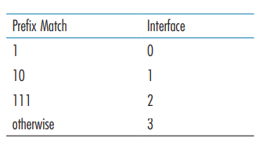

**For each of the four interfaces, give the associated range of destination host addresses and the number of addresses in the range.**

Interface 0

Range: 00000000 through 00111111

Number of addresses: 64

Interface 1

Range: 01000000 through 01011111

Number of addresses: 32

Interface 2

Range: 01100000 through 01111111 10000000 through 10111111

Number of addresses: 96

Interface 3

Range: 11000000 through 11111111

Number of addresses: 64